**LinkedIn Profile Analytics Dashboard Project 2024 in Power BI**

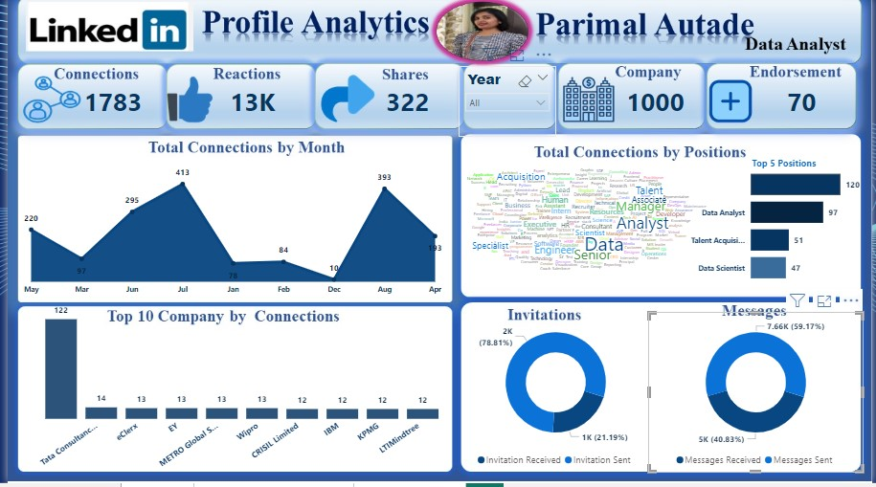

**Case study 6:**

**Problem Statement:**

As a data professional, the challenge is to extract, clean, and analyse LinkedIn data to generate actionable insights for enhancing personal and professional networks. The key objectives include understanding engagement metrics (likes, shares, reactions), monitoring the growth of connections over time, and identifying key influencers and top companies in your network. This project will leverage Power BI's capabilities to transform raw LinkedIn data into a comprehensive dashboard that tracks key performance indicators (KPIs) such as total connections by month, top positions held by connections, company-wise connections, endorsement patterns, and follower growth

### Learning Outcomes:

* **Data Extraction:** How to extract and import LinkedIn data into Power BI.
* **Data Transformation:** Techniques for cleaning and transforming LinkedIn data to ensure consistency and accuracy.
* **Measure Creation:** Understanding how to create custom measures in Power BI to track specific metrics like total endorsements, shares, and reactions.
* **Calendar Table Creation:** Building a calendar table in Power BI to facilitate time-based analyses, such as tracking monthly connection growth or seasonal engagement trends.

**Key Performance Indicators (KPIs)**:

1. Total Connections by Month: Measures the monthly growth of LinkedIn connections to track networking progress.

2. Top 10 Companies by Connections: Identifies the companies with the highest number of connections, reflecting your network's corporate affiliations.

3. Top 5 Positions Held by Connections: Highlights the most common job roles within your LinkedIn network.

4. Engagement Metrics (Likes, Shares, Reactions): Evaluates the effectiveness of posts through the number of interactions received.

5. Endorsements by Skill: Tracks the frequency of skill endorsements to understand how your expertise is perceived.

6. Follower Growth: Monitors the increase in LinkedIn followers over time, indicating your influence.

7. Invitation Messages: Counts the number of incoming connection requests, reflecting networking outreach efforts.

**Data Preparation:**

* Data **Cleaning**: Removing duplicates, handling missing values, and ensuring data consistency (like renaming columns or standardizing formats) to make the data accurate and reliable.
* Data **Transformation**: Filtering out irrelevant data, merging tables, and creating new columns or measures to make the data easier to analyse and align with the KPIs you've set.
* 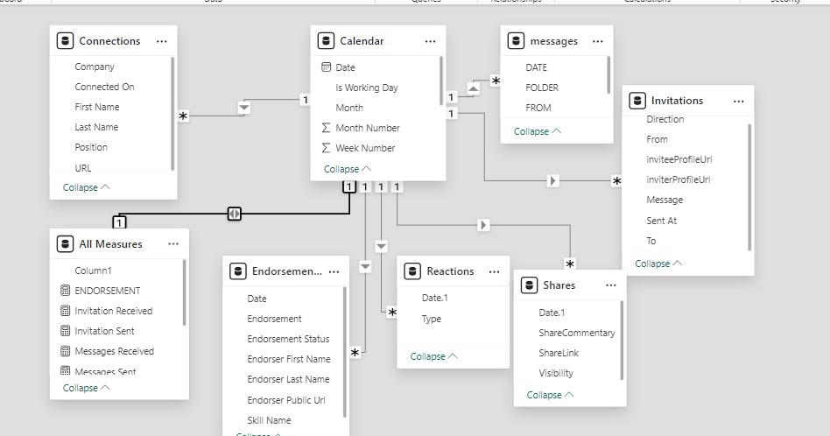

**Conclusions:**

This LinkedIn Dashboard project shows how data visualization can support smart decisions in a professional setting. By analysing LinkedIn data,

We have created a tool that helps stakeholders track networking trends, spot key influencers, and improve outreach strategies.

The dashboard's insights into connection growth and engagement provide a clear view of one's professional network.

For students, this project underscores the importance of aligning data analysis with real-world job needs, ensuring that the insights are useful and relevant. This approach not only boosts professional growth but also equips them to create dashboards that meet the needs of recruiters and businesses.